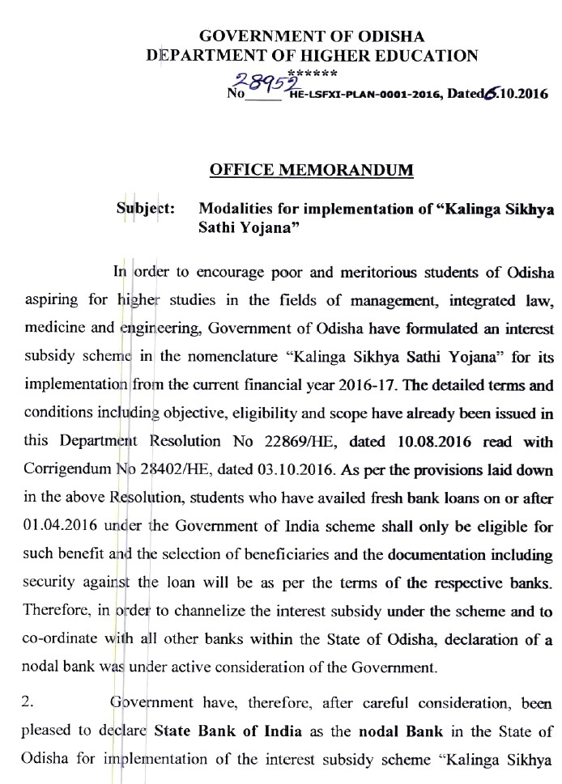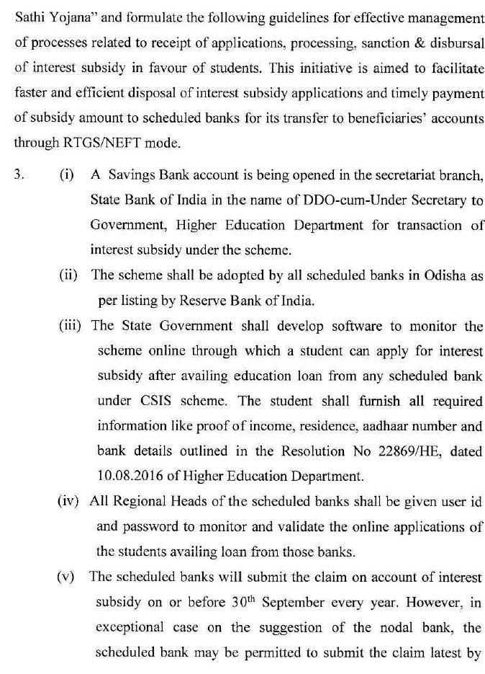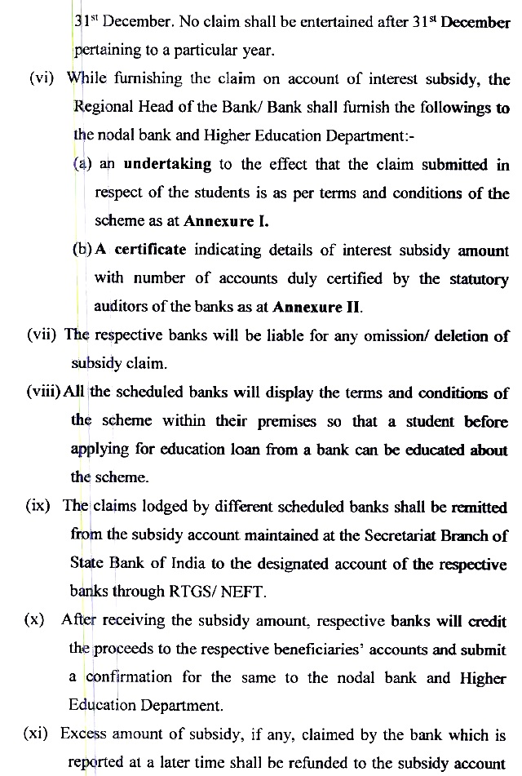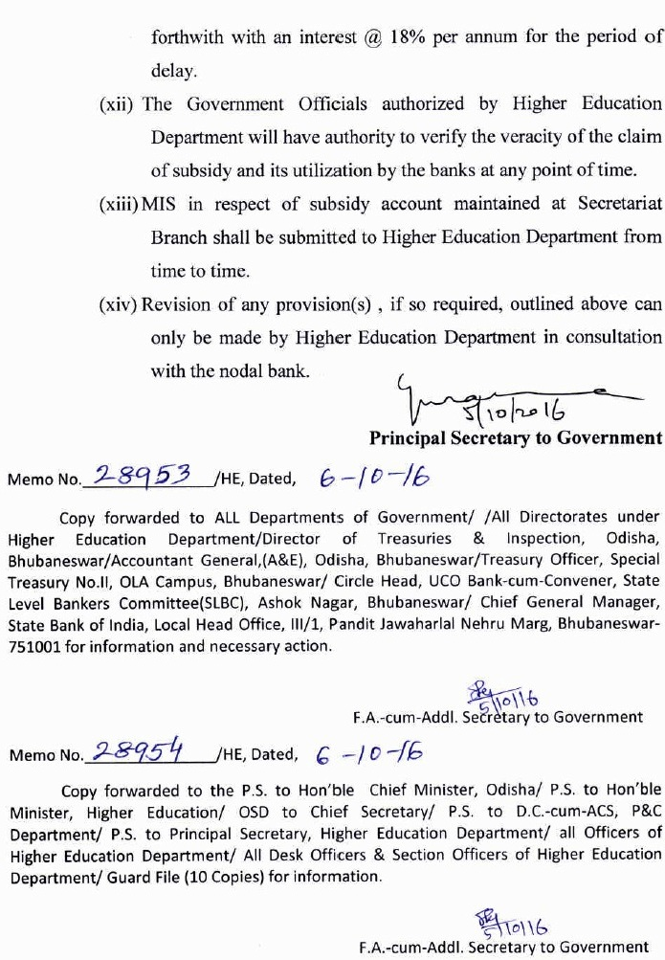
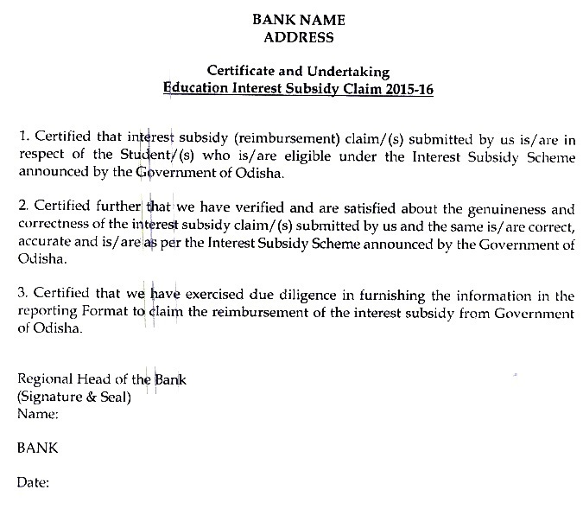

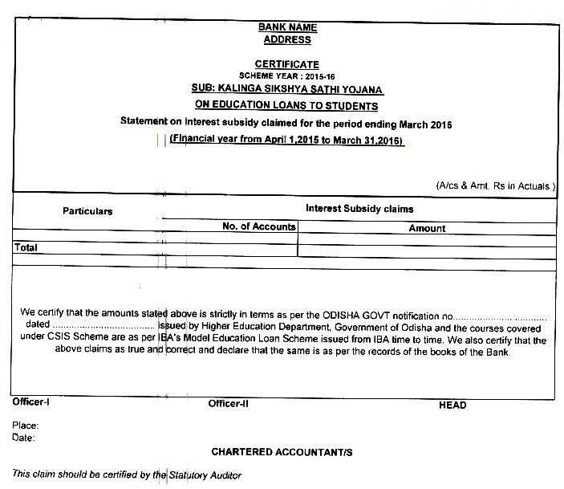

Highlights of Kalinga Sikhya Sathi Yojana

Govt. of Odisha has introduced new interest subsidy Scheme on Education Loan namely KALINGA SIKHYA SATHI YOJANA w.e.f . 01.04.2016.

1. Name of the Scheme-KALINGA SIKHYA SATHI YOJANA
2. Purpose Interest subsidy on Education Loan will be provided by Govt. of Odisha.
3. Courses to be covered: Higher studies in the field of Engineering, Medicine, Management and Integrated Law in any approved Institution in India.
4. Periodicity of loan:
i) For loan amount up to Rs 7.5 lakh Repayment period is 10 Years including Moratorium Period
ii) For Loans above Rs 7.5 Lakh to Rs 10 Lakh: Repayment period is 15 years including Moratorium Period.
5. Eligibility: i) Must be resident of Odisha.
ii) Annual parental Income must be below Rs 6 lakh.
Iii Loan amount should be up to Rs 10 lakh
iv) Must have availed Education loan from any Bank in Odisha.

Note1: The residential certificate shall be issued by the Revenue Officer not below the rank of Additional Tahasildar for the above purpose.
Note 2: The income certificate can either be self-certified based on the copy of the validly submitted Income Tax Returns(for parental income above Rs 4.5 lakh to below Rs 6 Lakh) / or it can be a certificate issued by Revenue Officer not below the rank of Additional Tahasildar.

6. Rate of Subsidy: Subsidy will be provided at such a rate that the net interest
Payable by student is @1 %
a) For student’s whose parental income is up to Rs 4.5 lakh: Interest subsidy will be provided after Moratorium Period(only to those borrowers who are covered under CSIS) till closure of the loan(as the interest subsidy during moratorium period is provided by GOI under CSIS)
b) For students having parental Income more than Rs 4.5 lakh to below Rs 6 lakh: Interest subsidy will be provided by Govt. of Odisha from date of disbursement till closure of the loan.

Modification in “Kalinga Sikhya Sathi Yojana”
In respect of education Loans for students of Odisha pursuing higher studies in technical/professional courses by Government of Odisha.

In substitution of Para 6 of the Resolution No.22869/HE, Dated 10.08.2016 and in partial modification of Para 2 of the Corrigendum no.28402/HE, dated 03.10.2016, the following change in the Scheme will apply:

Interest subsidy will be provided if the repayment of loan is regular. Temporary default in repayment of loan up to a period of 90 days is permitted for payment of interest subsidy. The interest subvention towards penal interest, if any, charged by bank for the default period will not be borne by Government. The total period of repayment as mentioned in the guideline will not be enhanced.

- If any default in repayment of loan beyond 90 days is corrected by the borrower through repayment of arrear interest and principal and the NPA a/c becomes a standard account, the benefit of interest subvention will apply from the date when the bad loan/NPA again turns ‘standard’. Interest subvention towards penal interest, if any, charged by the bank will not be borne by Government. The total period of repayment as mentioned in the guide line will not be enhanced.
- Interest subsidy shall be provided in case of fresh education loans sanctioned after 01.04.2016.The interest subsidy shall be paid to bank from which the student has availed the loan.
- The interest subsidy during the moratorium period in respect of students with annual parental income exceeding Rs.4.50 lakh but less than Rs.6.00 lakh, i.e. those who have not been covered under Government of India Scheme, shall be borne by the Government of Odisha.”

The Corrigendum shall come into force with immediate effect. All other provisions as in the aforesaid Resolution and the Corrigendum shall remain unchanged.

Under KSSY, all Commercial banks have disbursed Rs 6.39 Crore in 226 accounts during 01/04/2017 to 30./06/2017. The balance outstanding as on 30.06.2017 is Rs 36.11 Crore in 2050 accounts.

Kalinga Sikhya Sathi Yojana (KSSY) || Educational Loan
The Odisha Government has come up with a new scheme named as Kalinga Sikhya Sathi Yojana (KSSY) for the aspiring students at only 1% interest. It has been launched by Hon’ble CM of Odisha, Shri Naveen Patnaik on 27th June 2016. This scheme has been launched to bring down the financial burden on the parents of the students who want to move forward with higher education.

Details about the scheme Kalinga Sikhya Sathi Yojana
A student can avail loan under the scheme “Kalinga Sikhya Sathi Yojana” from scheduled banks for pursuing higher studies. The scheme will give them up to 10 lakh rupees to proceed for the higher courses.
- Maximum Loan: According to the rules of the scheme, a student can get maximum of 10 lakh rupees as an educational loan under this scheme.
- Minimum Loan: There is no minimum loan amount mentioned in the scheme. One can get any amount of loan up to Rs. 10 lakh.
- Period of Loan: The period of repayment will be up to 10 years and 15 years in respect of loan sanctioned up to 7.5 lakhs and 10.00 lakhs respectively.
- Rate of Interest: The applicants will have to pay only 1% interest on the loan amount. The balance amount of the interest will be borne by Government of Odisha, Higher Education Department.

Eligibility Criteria
- The student must be a resident of Odisha.
- As per the eligibility criteria, the annual income of the family of the applicant must be between 4.5 lakhs to 6 lakhs per annum. The terms are conditions of loan will be as per norms of individual schedule banks. The loan applications will be processed by the rules of the banks. The poor students who are willing to continue higher studies can apply for the loan under this scheme

Moratorium period of the loans
Generally, the moratorium period of education loans is course period plus one year depending on the banks. But under KSSY, the financial assistance in the form of interest subvention shall be provided for the period of repayments including moratorium period after the completion of course. This will prove to be very beneficial to students.

